**Pearland Police Department**

Vehicle Pursuit Report

2023



This analysis was conducted for the purpose of reviewing the Pearland Police Department’s Vehicle Pursuits for calendar year 2023. Vehicle Pursuits are inherently dangerous to both the officers involved and the public. The Pearland Police Department takes its obligations seriously to provide the most effective and efficient police service with the least adverse impact on our citizens. The Pearland Police Department is committed to protecting our citizens but at the same time ensuring the manner in which we do so does not place the public at risk of greater harm. This process requires continuous evaluation of the risks and benefits of each action. This analysis is conducted each year to comply with Texas Law Enforcement Best Practice 7.14 and to attempt to identify methods for reducing the number of vehicle pursuits and the inherent risks involved.

Officers are trained by the department in pursuit tactics and emergency driving. However, as skilled as an officer might be in these situations, the vehicle being pursued may not have a competent driver and many times the driver may be under the influence of alcohol or drugs.

Texas Law Enforcement Best Practice 7.13 and Pearland Police Department Policy 504, requires a written report be completed anytime an officer pursues a vehicle.

Any time an officer calls a pursuit, department policy requires a supervisor be immediately notified by the Dispatch center. The supervisor is required to monitor the pursuit and act as an uninvolved decision maker regarding the danger of the pursuit. Both the officer and Supervisor are charged with continuous evaluation of the pursuit as it occurs and are required to call off the pursuit when either believe the risks to the officer or public outweigh the need for immediate capture of the suspect.

Each individual Pursuit Report is immediately reviewed by the Officer’s Supervisor, and through the Chain of Command to the Chief of Police. At the time of the incident, the Pursuit is reviewed to ensure the use was appropriate and within the guidelines of Department Policy. If the officer initiated a pursuit inappropriately, a departmental investigation is required, and the officer may receive additional training or in some cases discipline up to and including termination from employment.

There were 44 vehicle pursuits reported and documented as required by Department Policy. 42 of those pursuits were initiated by the Pearland Police Department while the remaining two pursuits were initiated by other agencies that passed through Pearland in which units from the Pearland Police Department assisted. The reporting and analysis documented in this report will focus primarily on those pursuits initiated by the Pearland Police Department. The number of vehicle pursuits in 2023 was down 25% over the year prior.

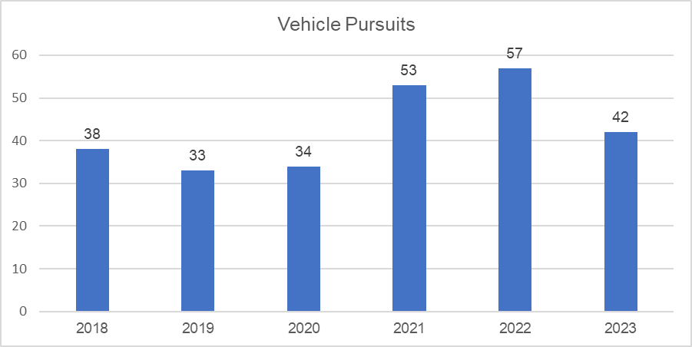

57% of the vehicle pursuits occurred during nightshift hours (6pm to 559am)

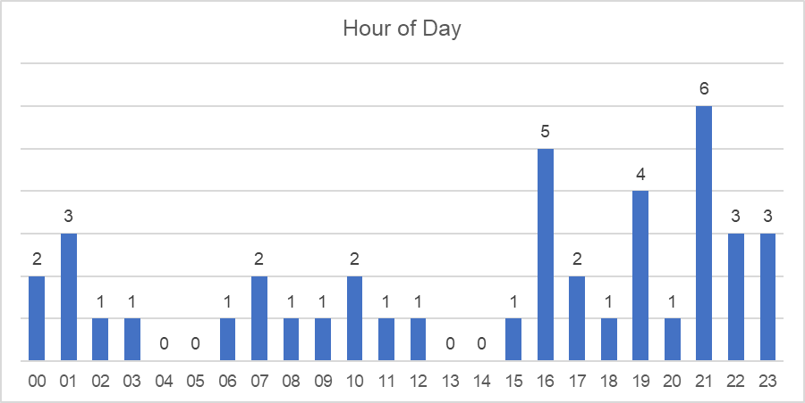

Of the 42 pursuits initiated by the Pearland Police Department, 30% originated from an observed traffic violation. 13 of the 15 pursuits stemming from a criminal investigation were originated by a citizen calling in the event to the police. Nine pursuits originated from License Plate Recognition alerts. Officers conducted just over 29,200 traffic stops last year and 16 (.05%) pursuits originated from traffic stops. A breakdown of the reason for the pursuits is depicted in the chart below.

|  |  |  |  |  |  |  |
| --- | --- | --- | --- | --- | --- | --- |
| **Reason** | **2018** | **2019** | **2020** | **2021** | **2022** | **2023** |
| Criminal Investigation | 9 | 21 | 17 | 21 | 19 | 15 |
| DUI / DWI | 6 | 2 | 2 | 1 | 1 | 2 |
| Equipment Violation | 6 | 2 | 4 | 5 | 5 | 2 |
| LPR Hit | - | - | - | - | 3 | 9 |
| Traffic Violation | 14 | 6 | 10 | 25 | 23 | 13 |
| Wanted Vehicle / Driver | 3 | 2 | 1 | 1 | 6 | 1 |
| **Total** | **38** | **33** | **34** | **53** | **57** | **42** |

The average pursuit distance was two miles with 9 pursuits traveling one mile or less. The longest pursuit lasted 18 miles. The average top speed was 90 mph and top speeds ranged from 48 mph to 120 mph. About half (47%) of pursuits involved a single police vehicle. A breakdown in the number of department vehicles involved in pursuits is depicted in the chart below.

|  |  |
| --- | --- |
| **# Police Vehicles** | **Pursuits** |
| 1 | 20 |
| 2 | 7 |
| 3 | 7 |
| 4 | 3 |
| 5 | 3 |
| 6 | 1 |
| 7 | 1 |

Safety of the officers, the evading suspects and the general public is important in considering when to initiate a pursuit and when to terminate them. Of the 42 pursuits initiated by the Pearland Police Department, 16 of those were terminated. Aside from when a suspect successfully evades officers, often due to officers losing sight of the evading vehicle, reasons for termination are almost always for reasons of safety. Termination reasons are found in the chart on the following page.

|  |  |
| --- | --- |
| **Termination Reason** | **Count** |
| Level of Offense | 1 |
| Other | 1 |
| Speed | 2 |
| Supervisor Order | 1 |
| Suspect Evaded | 8 |
| Traffic Conditions | 3 |
| **Total** | **16** |

Out of the total documented 44 pursuits, there were no officers injured. Three pursuits resulted in a suspect receiving injuries. Two pursuits ended in single vehicle collisions. One of those pursuits did result in the death of one of the fleeing suspects and an injury to the passenger of the fleeing vehicle. The driver in that pursuit lost control of the vehicle while attempting to make a left turn and crashed into a light pole. Another pursuit resulted in the life flighting of the driver of the fleeing vehicle. The third pursuit resulted in minor injuries to the fleeing driver.

Crashes are an inherent risk when dealing with pursuits. Officers receive hours of training on vehicle operation and police vehicles enjoy a reasonably high level of maintenance, while those being pursued have no training and often have vehicles with questionable equipment and maintenance history. Seven pursuits ended as a result of the evading vehicle crashing. One of those crashes involved the evading vehicle hitting another car. Two citizens received minor injuries in that crash. The chart below shows a breakdown of how pursuits have ended.

|  |  |
| --- | --- |
| **Pursuit Ended** | **Count** |
| Crash | 7 |
| Other | 3 |
| Suspect Evades | 2 |
| Suspect Voluntarily Stopped | 16 |
| Terminated | 16 |
| **Total** | **44** |

People try to evade police for several reasons, many are just trying to avoid arrest. Looking at the pursuits that were initiated by Pearland, 22 of the 42 drivers were arrested at the scene. Further, 11 of the drivers continued to flee on foot after the vehicle pursuit ended. Of the known drivers, 11 were not licensed to drive and three had a suspended driver’s license. Two drivers were found to be intoxicated.

Two pursuits resulted in use of force requiring a use of force report be documented. Use of force is governed by Policy 502 and a detailed report on the Pearland Police Department’s use of force events can be found on the Department’s website.

Of the 44 documented pursuits in 2023, seven pursuits had policy violations. The policy violations did not result in any injuries or property damage and the majority were resolved through counseling or additional training for officers involved. One policy violation resulted in a two-day suspension for the officer involved.