To apply for a City of Pearland Right of Way Permit, please follow the following steps. Should you have any questions or comments please contact the Right of Way office at 281-652-1900.

**Step 1** - For first time applicants to the online system, please contact the Community Development Department at 281-652-1638 email address  [permits@pearlandtx.gov](mailto:permits@pearlandtx.gov). to setup an account.

**Step 2** – Access the City of Pearland’s Community Development Web Portal at <http://etrakit.pearlandtx.gov/etrakit3/>the home screen will appear as the following:

Step 3 – In the log in section at the top of the home screen select “**Contractor**” in the drop down menu



Step 4 – Enter the **“Username”** provided by Community Development Department in the login area.

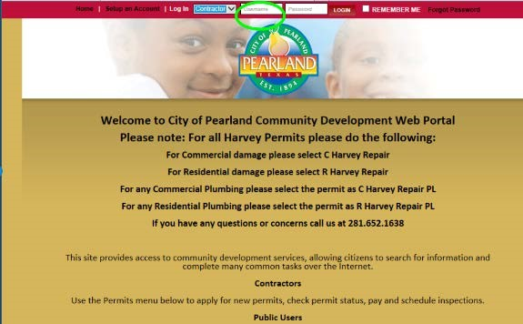

Step 5 – Enter the **“Password”** provided by Community Development Department in the login area.

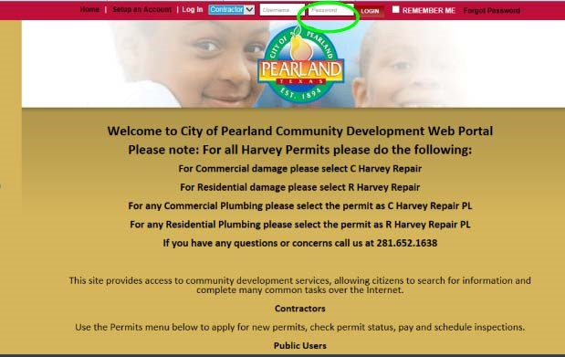

Step 6 – Select the **“login”** button next to the password area.



Step 7 – Once you are logged in, the scree will appear similar to the following.

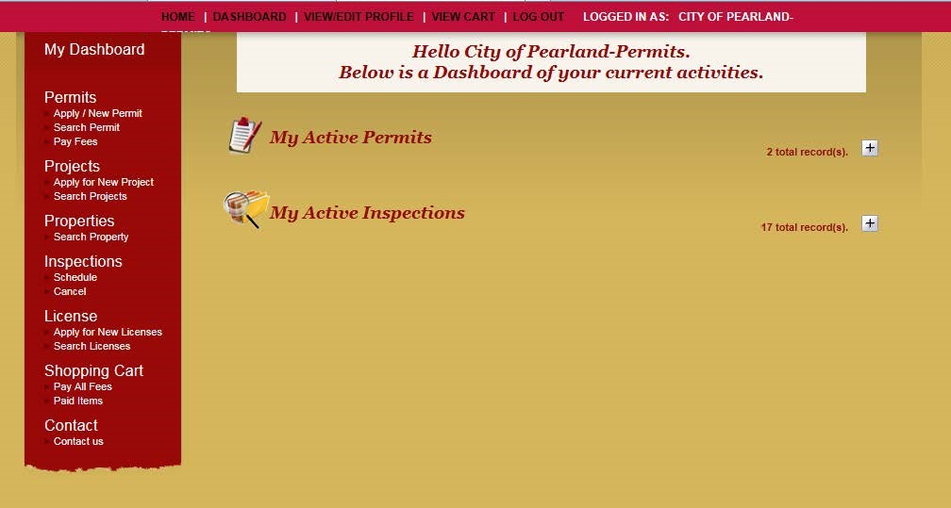

Step 8 – To apply for a new Right of Way (ROW) Permit, select the **“Apply / New Permit”** option under “My Dashboard”

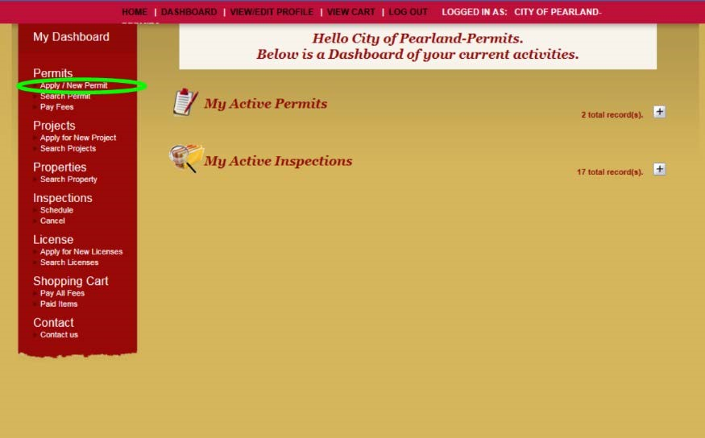

Step 9 – Read the Disclaimer for applying for City of Pearland permits. Select “I Agree” if you agree to the terms of the permit submission.

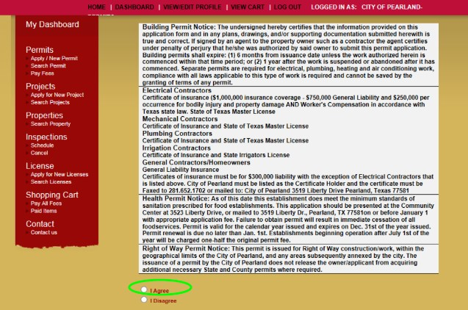

Step 10 – Select “Continue” to advance to permit application process.

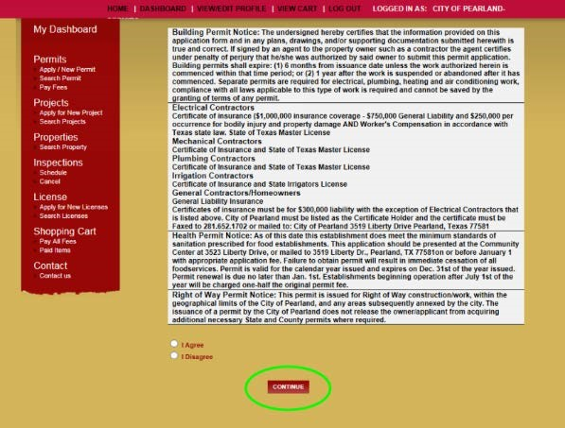

Step 11 – Permit application page will appear as the following.

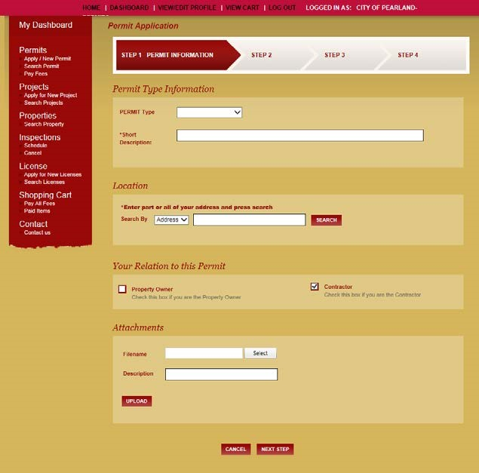

Step 12 – On the step 1 page (identified in red at the top of the screen), select **PERMIT Type** drop down option.

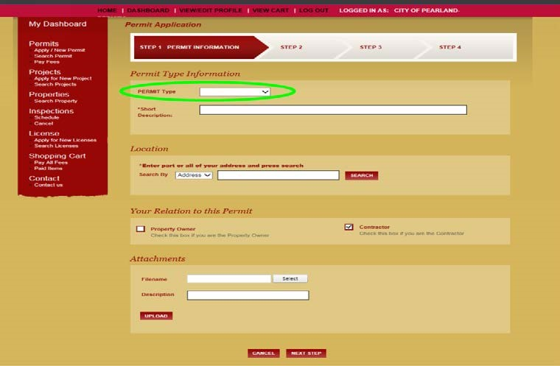

Step 13 – Select the RIGHT OF WAY option in the drop down menu.

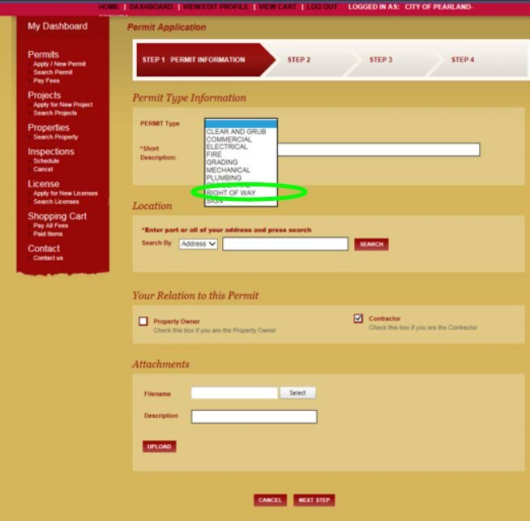

Step 14 - On the step 1 page (identified in red at the top of the screen), select **PERMIT Subtype** drop down option.

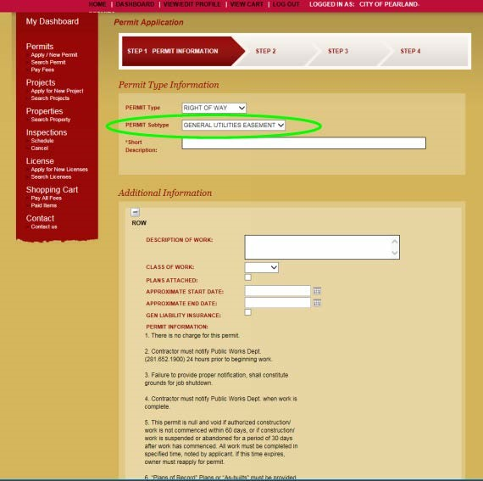

Step 15 – Select the entity’s name for the utility company applying for the permit. (Example – At&t will select ROW ATT, CenterPoint Electric will select ROW CENTERPOINT ELECTRIC, CenterPoint Gas will select ROW CENTERPOINT GAS, Comcast will select ROW COMCAST. All other entities will select ROW OTHER)

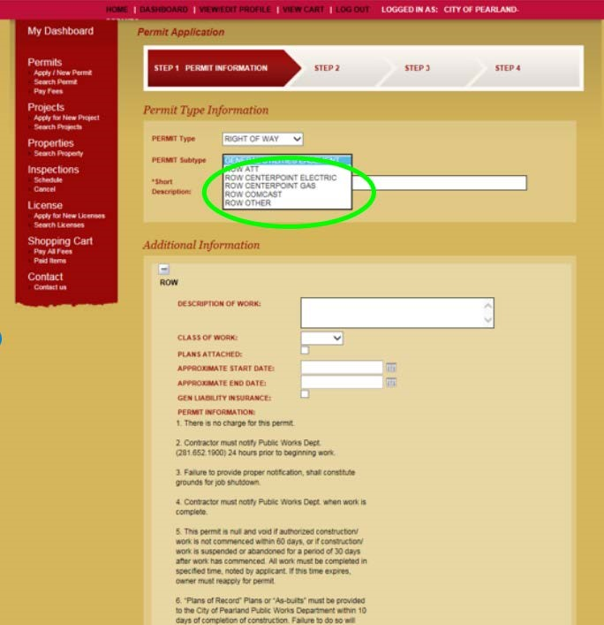

Step 16 – For the purposes of this example work flow, we will select “**ROW Other**”.

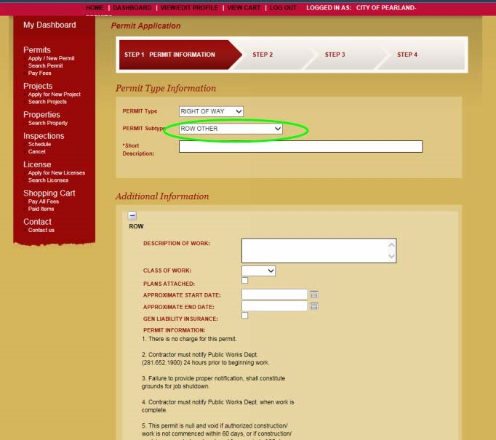

Step 17 – In the **Short Description** area, write a brief description of work to take place under within the requested permit application. Example *-“Installing underground fiber optic cable*.”

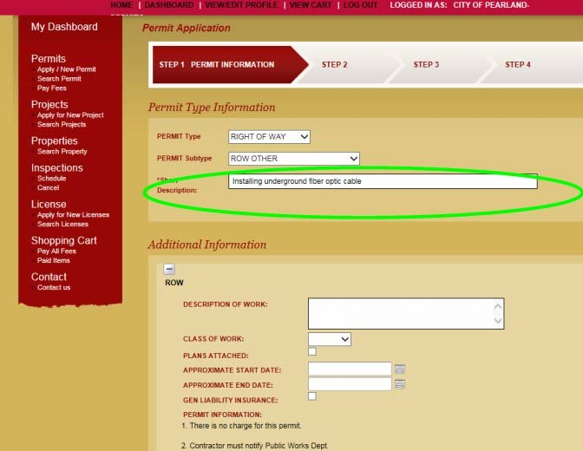

Step 18 – In the Additional Information section, under **DESCRIPTION OF WORK** include the detailed description of work to take place under this permit. This description should match what was previously provided in the emailed application process. Example – “Installation of 350’ of new underground fiber optic cable from 3501 e. orange to 3509 e. orange in the right of way along Orange Street.“

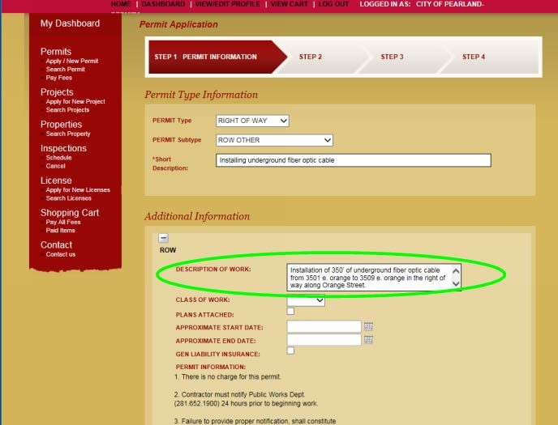

Step 19 – In the Additional Information section, under **CLASS OF WORK** select the drop down menu to choose if the work requested under the applied for permit is the placement of new facilities or to repair existing facilities.

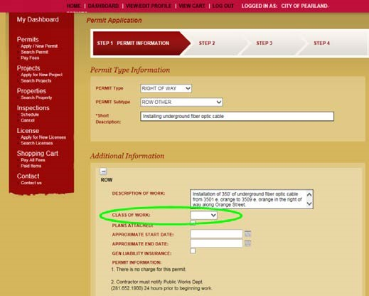

Step 20 – For the purposes of this example work flow, we will select “New” but please select the appropriate option for your application.

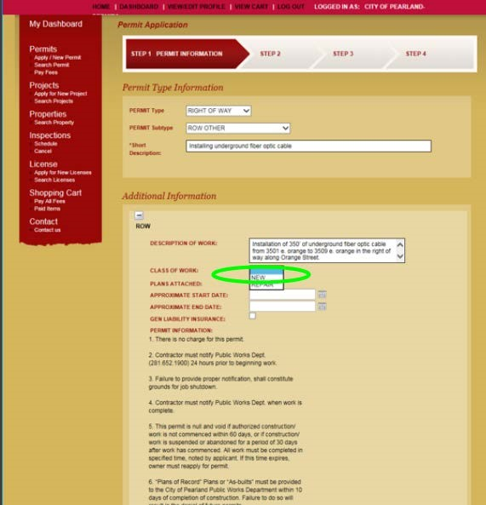

Step 21 – Skip over the **“PLANS ATTACHED”** section at this time.

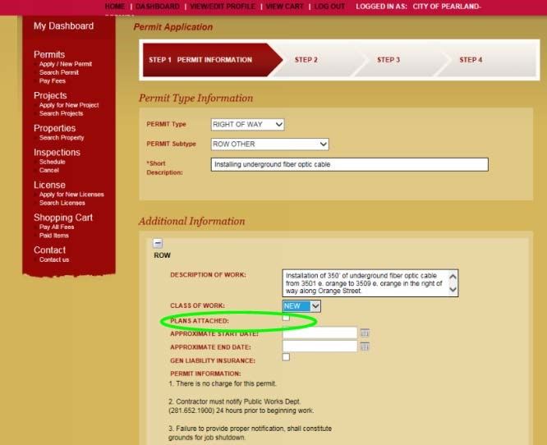

Step 22 – Proceed to the APPROXIMATE START DATE, enter the date that applicant plans to begin construction. The calendar option to the right of the fillable space allows applicant to select date.

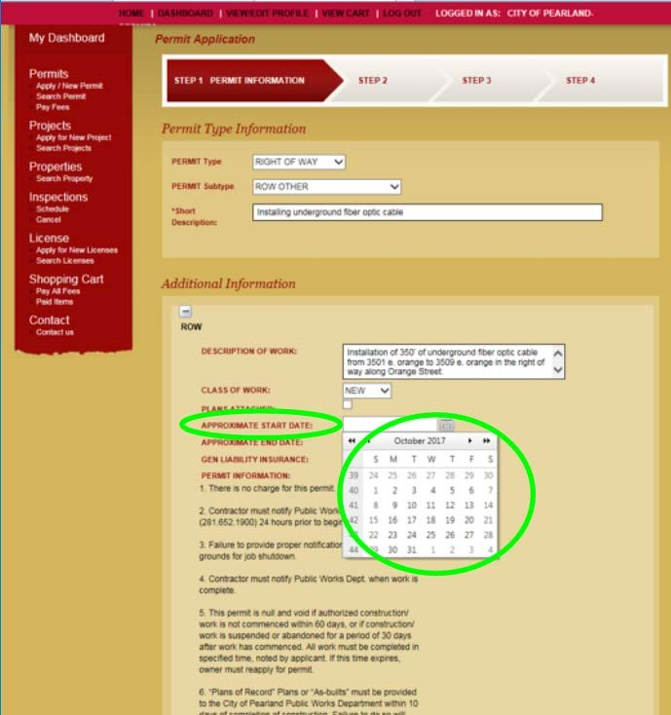

Step 23 – Proceed to the APPROXIMATE END DATE, enter the date that applicant plans to complete the construction.

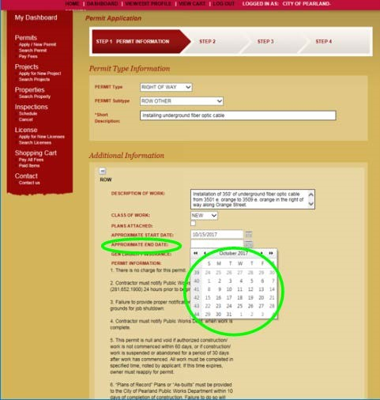

Step 24 – **GEN LIABILITY INSURANCE**. Under Chapter 26 of the City of Pearland Code of Ordinances, Section 26-88 (b) (7), right-of-way permit applicants are required to provide insurance and bonds for requested work. Chapter 26 can be reviewed at the following link for identification of necessary coverage. [https://library.municode.com/tx/pearland/codes/code_of_ordinances?nodeId=COOR_CH26 RI-W](https://library.municode.com/tx/pearland/codes/code_of_ordinances?nodeId=COOR_CH26RI-W)  Once applicant has reviewed the necessary coverage and confirmed that coverage is on file with the City of Pearland Public Works Department, select the check box next to Gen Liability Insurance. (To contact the City of Pearland Public Works Department for confirmation of insurance on file or with questions, please contact Carlos Galvan or Eric Hammond at 281-652-1900.)

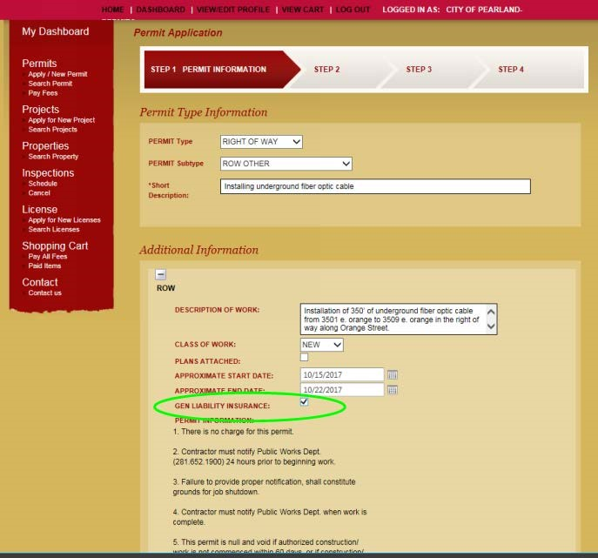

Step 25 - Review **PERMIT INFORMATION** items 1 – 9. Once applicant has reviewed the standard permit notes, check the “I agree” option in the dropdown menu.

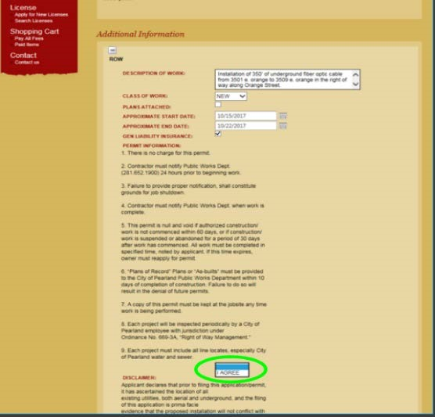

Step 26 – Review **DISCLAIMER**. Once applicant has reviewed the disclaimer that applicant has ascertained the location of all existing utilities and that application is prima facie evidence that proposed installation will not conflict with existing utilities, etc. Check the “I agree” option in the dropdown menu.

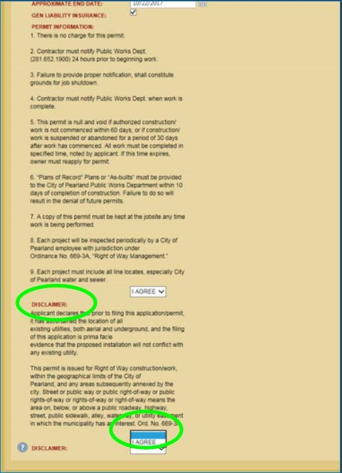

Step 27 – Review second **DISCLAIMER**. Click on  and review disclaimer related to the acquiring of necessary permits, agreeing to application being true & correct, complying with Ordinance and that submission of application constitutes an electronic signature, etc. Once applicant has reviewed, select the  button to return to the application screen. Once applicant agrees with all items, select the “I agree” option in the dropdown menu.

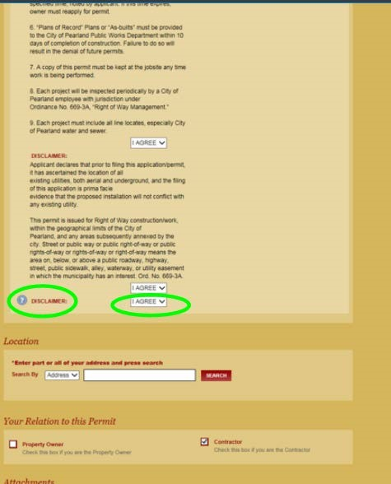

Step 28 – Location – For permits requested for a specific address, select “**Address**” in the drop down menu next to Search By.

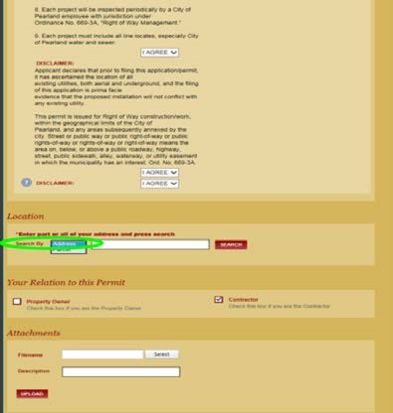

Step 29 – Location – For permits requested for a specific parcel or project not associated with a specific address, select **“Parcel”** (Example – repair work to underground fiber at the intersection of SH 35 and FM 518)

Step 30 – For permits assigned to a specific address, type the address into the text box next to the drop down menu. Once address has been inputted, select 

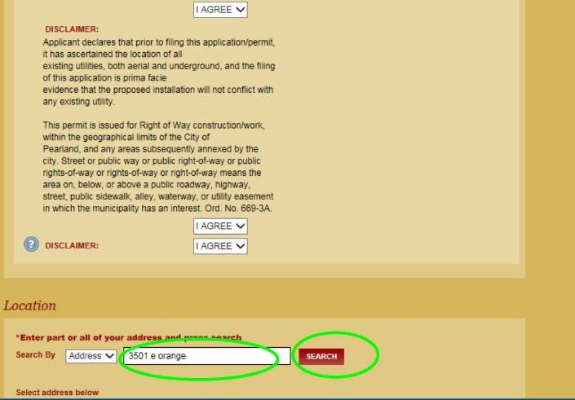

Step 31 – In the **Select Address Below** window, select the matching address associated with the proposed project.

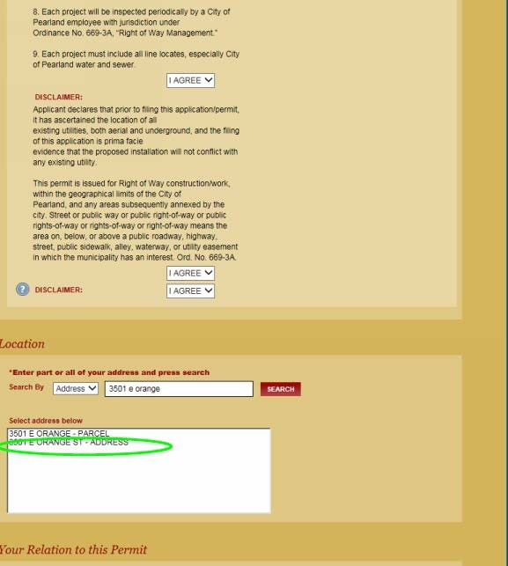

Step 32 – Confirm that in **the Your Relation to this Permit** section, ensure the “Contractor” checkbox has been selected. This check box should auto select as applicants will be log in as a contractor.

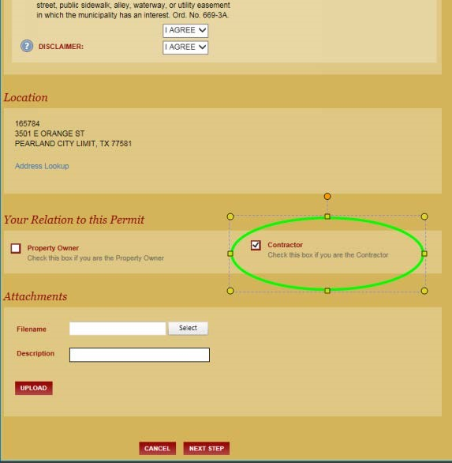

Step 33 – Attachments – To proceed in the **Attachment section**, applicants must upload associated construction drawings for the requested permit. Press the  icon and chose the file you wish to upload.

Step 34 – Attachments – upon successful completion of uploading an attachment should be listed below the  icon. (You can upload as many files as necessary and each will be listed in this area)

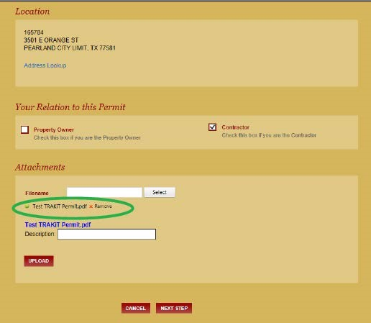

Step 35 – In the **Description** area, type in a brief description of the attachment that has been uploaded. For example – Test prints for underground fiber between 3501 and 3509 e Orange.

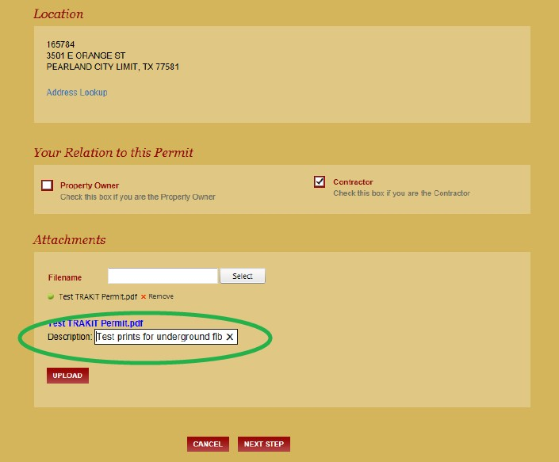

Step 36 – Now that plans have been attached, scroll back (up) to the Additional Information section of the page and check the “check box” next to the PLANS ATTACHED location.

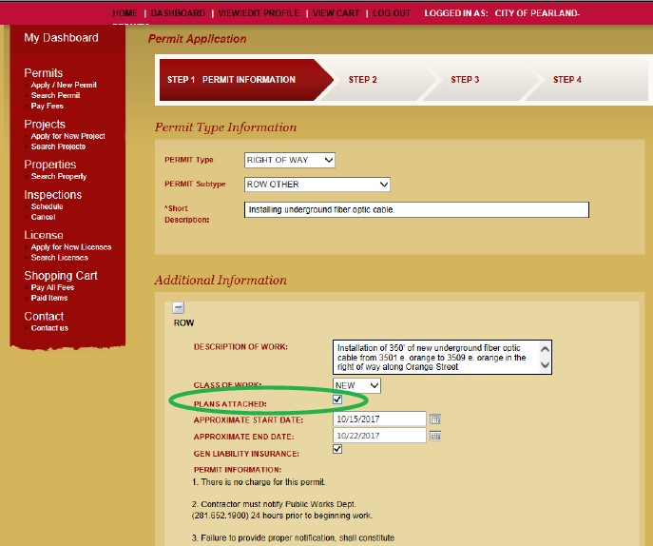

Step 37 – scroll back down to the **Attachment** section at bottom of the page and select the  icon.

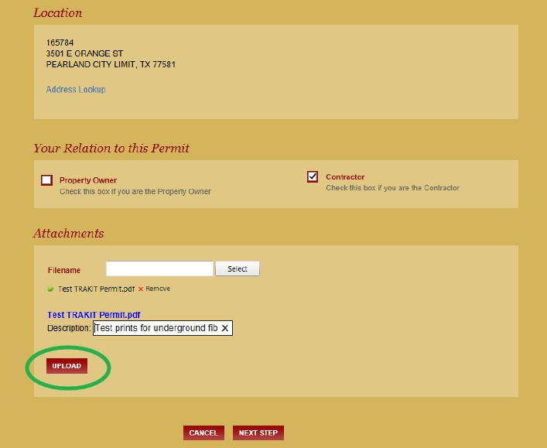

Step 38 – After upload is complete you will see the document and the brief description listed on the right hand side of the screen. The bold section becomes a link to the attachment that has been saved in the event you want to review before moving forward. (Image below is for reference only)

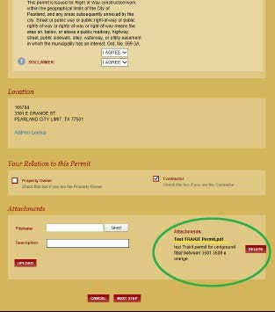

Step 39 – To proceed, press  at the bottom of the screen.

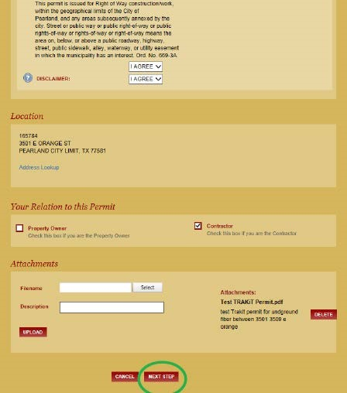

Step 40 – STEP 2 in the upper portion of the screen will be highlighted. To move forward fill all required blanks on the Contact Information page.

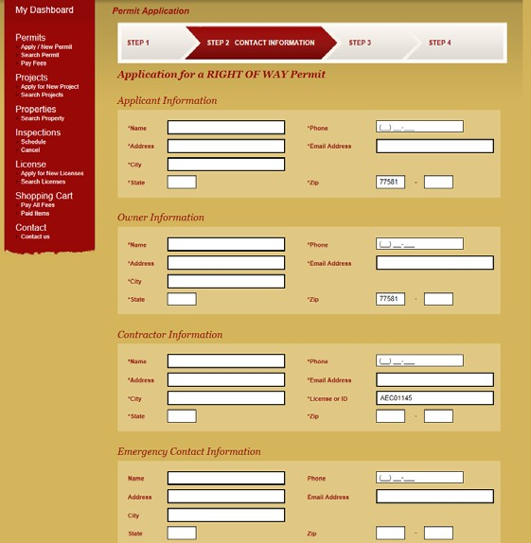

Step 41 – Once all blanks are filled, select the  button at the bottom of the screen.

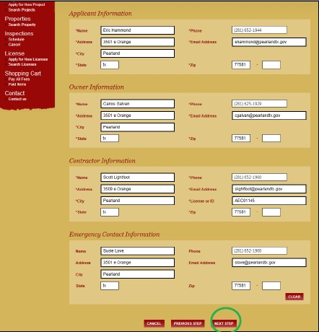

Step 42 – **STEP 3 REVIEW AND SUBMIT** will be highlighted at the top of the screen. Review all information carefully.

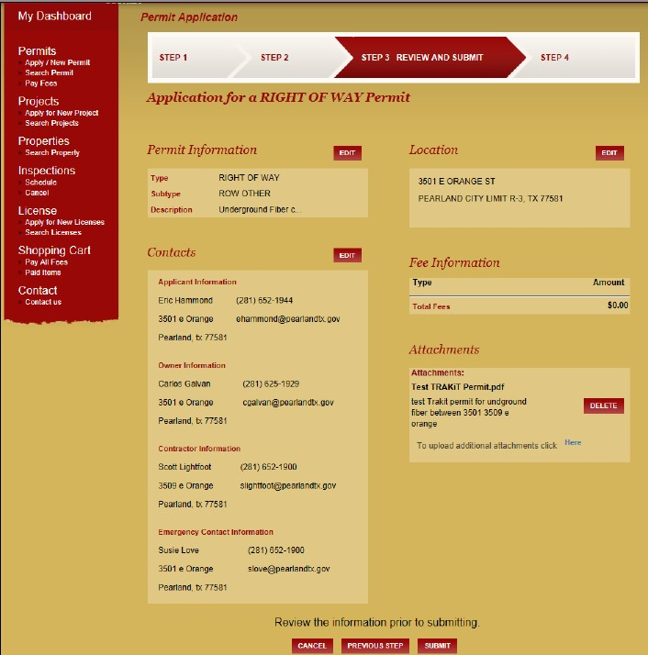

Step 43 – Once all information has been reviewed and permit is ready to be submitted for City review,

press the  icon at the bottom of the screen.

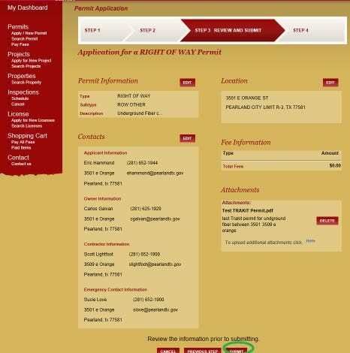

Step 44 – STEP 4 CHECKOUT/CONFIRMATION, once the permit has been submitted it is routed to the ROW Division’s queue for review and response. Please allow five business days for review. (From the review screen, applicants can also view the status of their permit and details thereof by selecting the

 icon.)

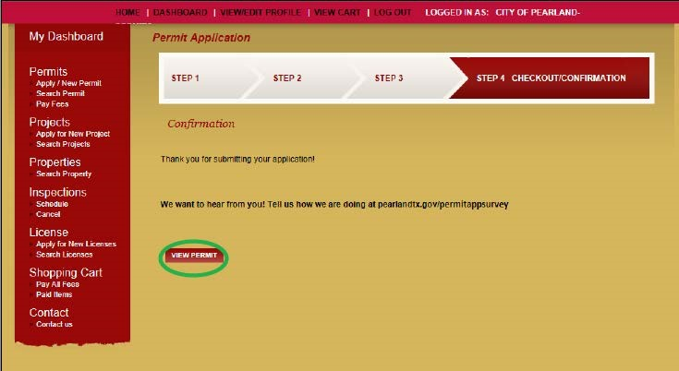

Step 45 – Upon review of the permit, applicants can now see the permit number assigned to the requested permit. This permit number is how staff and applicants should reference the permit moving forward. For example – Permit # **ROW17-00256**

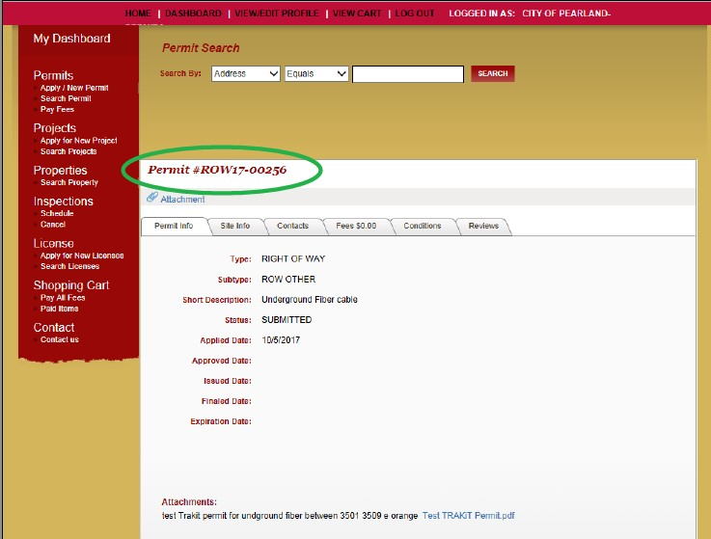

Step 46 – Applicants can review the status of their permit by perusing the selectable tabs highlighted in green below

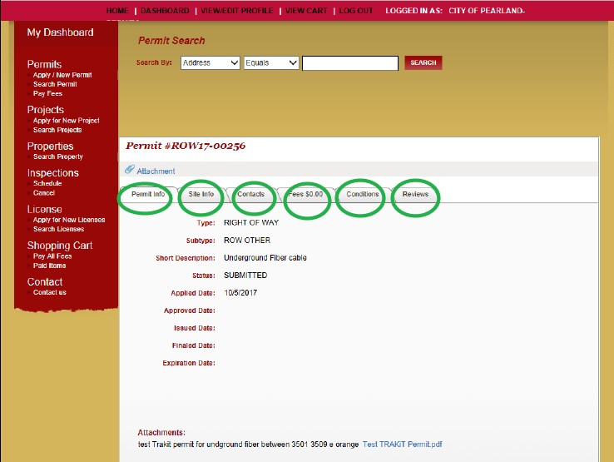

Step 47**- Completion**! Applicants can **log out** or select the Apply/New Permit screen to begin another permit application.

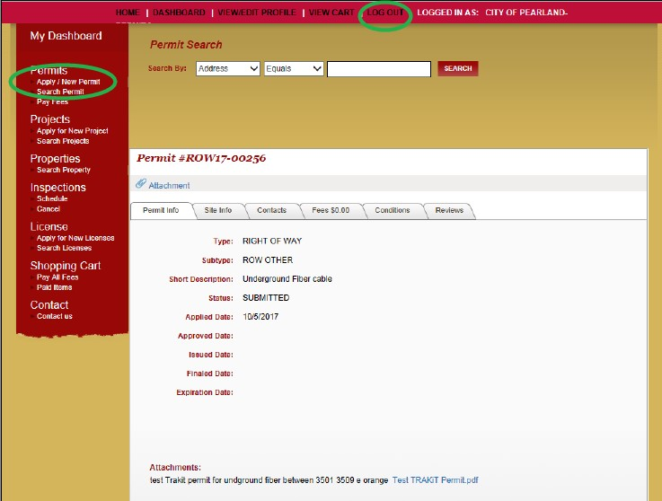

In the event you have any questions, please do not hesitate to contact the Public Works Right-Of-Way Team at 281-652-1900.

Step 48- Checking status of your permit. Applicants can periodically check the status of applied permits by viewing the **Permit Info** tab on each applied permit. The Permit Info tab is the first tab under the permit number.

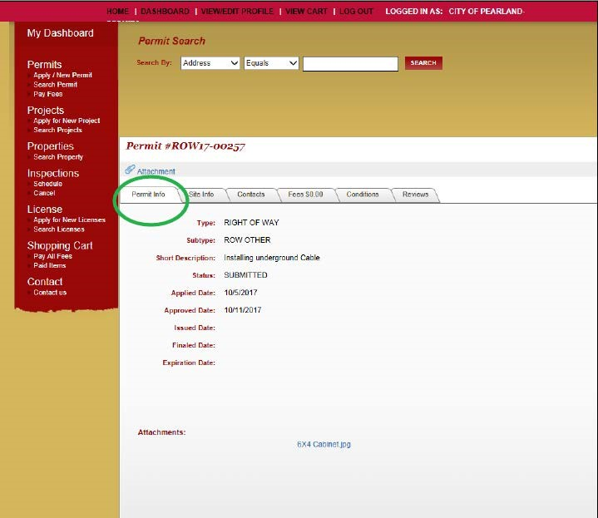

Step 49 – Checking status of your permit. To check the current status of an applied permit, view the **“Status”** area in the center of the page. When an application is first submitted it will state **“SUBMITTED**”

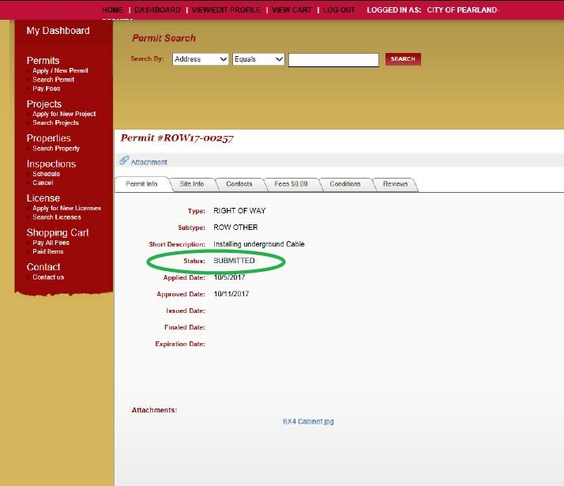

Step 50 – Remaining aware of **status changes** to your permit application. Permits are often reviewed within **7 days or 5 business days**. Applicants should log onto eTRAKiT periodically and check the status of an applied permit. Once a permit is reviewed and approved, the status will changed to PLANS APPROVED. (Note – comments or additional information may be necessary during the review and extend the standard review timeline.) Applicants should once again view the Status area on the Permit Info tab for update.

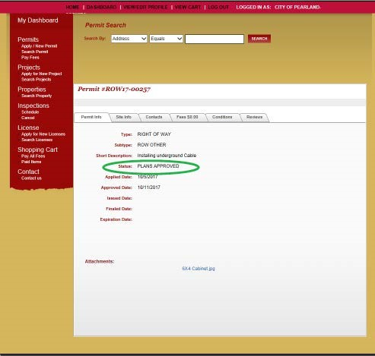

Step 51- **Activating a permit** and providing the required **24 hour advanced notification**. Once the status of a permit has changed to PLANS APPROVED and an applicant is ready to proceed with construction, a phone call to **281-652-1900** and request to activate a specific permit number is necessary. Following that phone call and activation discussion, staff will “activate” the permit and reply to the applicant with the activation number. Activation number and approved plans are required to be maintained in the field by contractor throughout construction.

Step 52 – **Checking status of your activated permit**. Applicants should check the status of their permit after “activating” a permit. To do so, view the status area under the Permit Info tab of a specific permit. The status should now reflect “**ACTIVATED”**

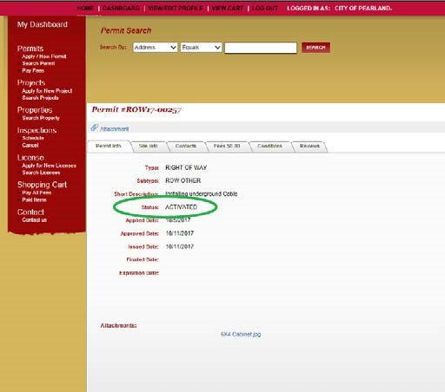

Step 53 – **Printing approved permit documents**. Once a permit is “activated”, applicants can print the necessary documents for contractor’s possession while in the field. **Authority** to operate under a permit **is contingent upon** a copy of said **permit being kept at the jobsite** any time work is being performed. Return to the Dashboard Screen by selecting Dashboard at the top of the screen

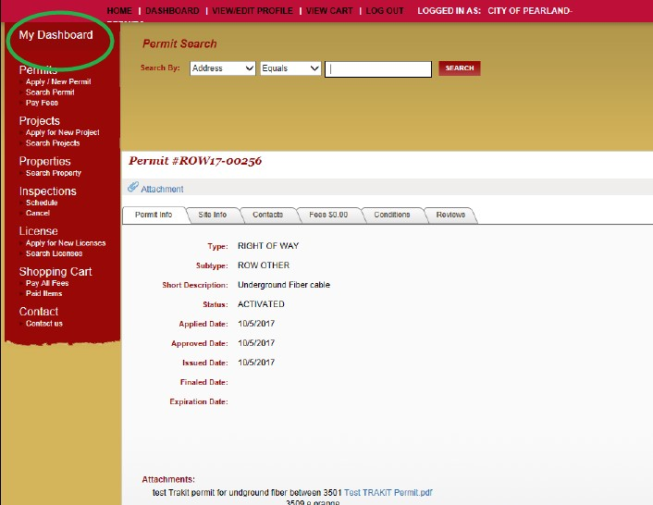

Step 54 – **printing approved permit documents** – From the **Dashboard** screen, select the permit you wish to print the documents from in the “**My Active Permit**” list. (Note - The quantity of permits listed on an applicant’s Dashboard with will vary depending on the quantity of applications they have submitted.)

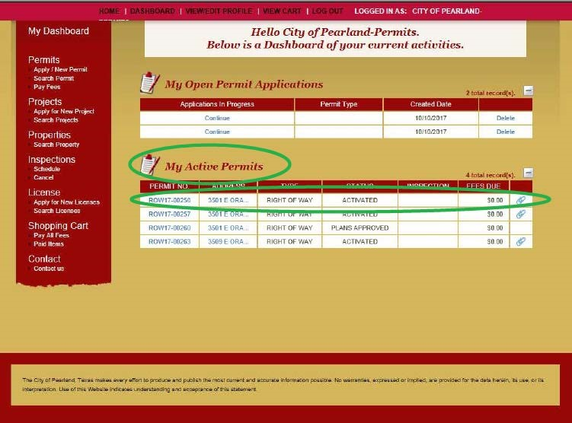

Step 55 – Printing approved permit documents continued – Select the  icon to the right of the permit selected for print.

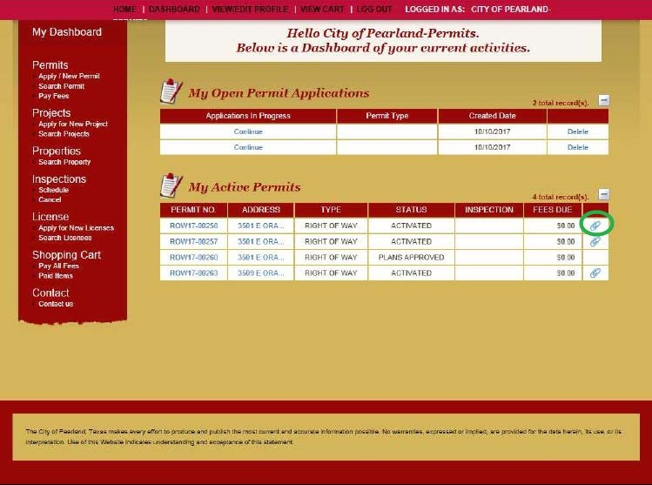

Step 56 – Printing approved permit documents continued – A **pop up window** will appear after selecting the paper clip icon.

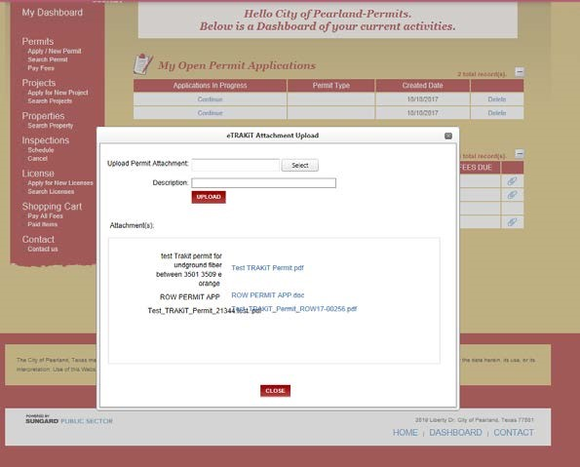

Step 57 – Printing approved permit documents continued – In the **pop-up window**, **hyperlinks** will be present that will access the submitted and approved documents. (Approved documents will have City stamps and logos attached)

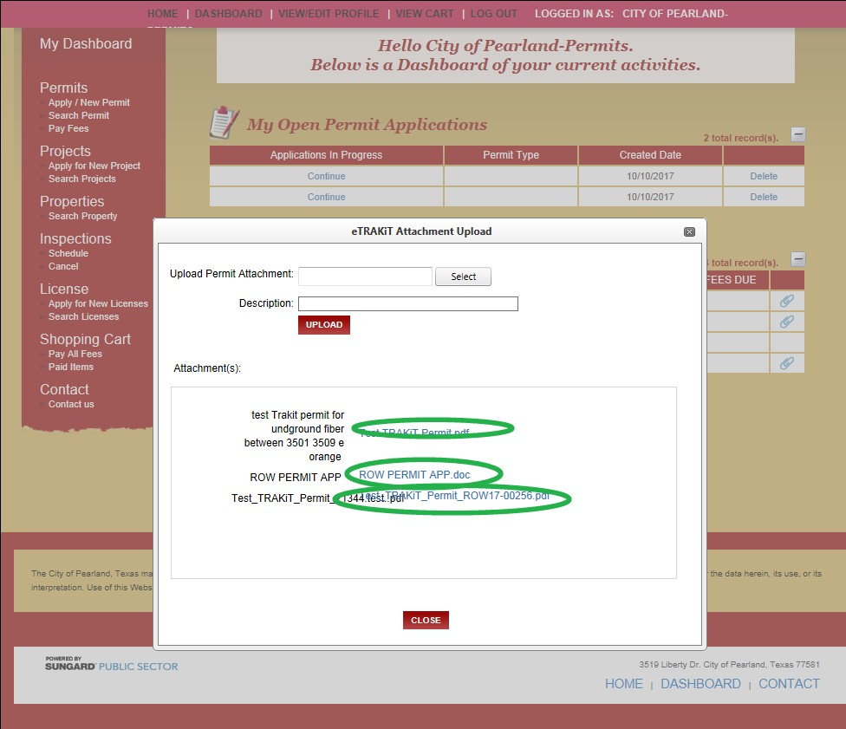

Step 58 – Select and print the links that have been “**Approved**” by the City. (Note – a document

approved by the City will have a **City Logo**  or w**atermark**  attached.

Step 59 – Printed documents maintained on-site while work is taking place, shall include the Approved permit application and Approved construction prints. (Examples below for example only).

