**Pearland Police Department**

Vehicle Pursuit Report

2021



This analysis was conducted for the purpose of reviewing the Pearland Police Department’s Vehicle Pursuits for calendar year 2021. Vehicle Pursuits are inherently dangerous to both the officers involved and the public. The Pearland Police Department takes its obligations seriously to provide the most effective and efficient police service with the least adverse impact on our citizens. The Pearland Police Department is committed to protecting our citizens but at the same time ensuring the manner in which we do so does not place the public at risk of greater harm. This process requires continuous evaluation of the risks and benefits of each action. This analysis is conducted each year to comply with Texas Law Enforcement Best Practice 7.14 and to attempt to identify methods for reducing the number of vehicle pursuits and the inherent risks involved.

Officers are trained by the department in pursuit tactics and emergency driving. However, as skilled as an officer might be in these situations, the vehicle being pursued may not have a competent driver and many times the driver may be under the influence of alcohol or drugs.

Texas Law Enforcement Best Practice 7.13 and Pearland Police Department Policy 504, requires a written report be completed anytime an officer pursues a vehicle.

Any time an officer calls a pursuit, department policy requires a supervisor be immediately notified by the Dispatch center. The supervisor is required to monitor the pursuit and act as an uninvolved decision maker regarding the danger of the pursuit. Both the officer and Supervisor are charged with continuous evaluation of the pursuit as it occurs and are required to call off the pursuit when either believe the risks to the officer or public outweigh the need for immediate capture of the suspect.

Each individual Pursuit Report is immediately reviewed by the Officer’s Supervisor, and through the Chain of Command to the Chief of Police. At the time of the incident, the Pursuit is reviewed to ensure the use was appropriate and within the guidelines of Department Policy. If the officer initiated a pursuit inappropriately, a departmental investigation is required, and the officer may receive additional training or in some cases discipline up to and including termination from employment.

There were 55 vehicle pursuits reported and documented as required by Department Policy. 53 of those pursuits were initiated by the Pearland Police Department while the remaining two involved pursuits initiated by other agencies that passed through Pearland in which units from the Pearland Police Department assisted. The reporting and analysis documented in this report will focus primarily on those pursuits initiated by the Pearland Police Department. The number of vehicle pursuits in 2021 was up 56% over the year prior. A review of these pursuits did not indicate any changes in department policy or operating procedure which may have contributed to the increase. At this time it is believed external factors beyond local law enforcement’s control may have played a part.

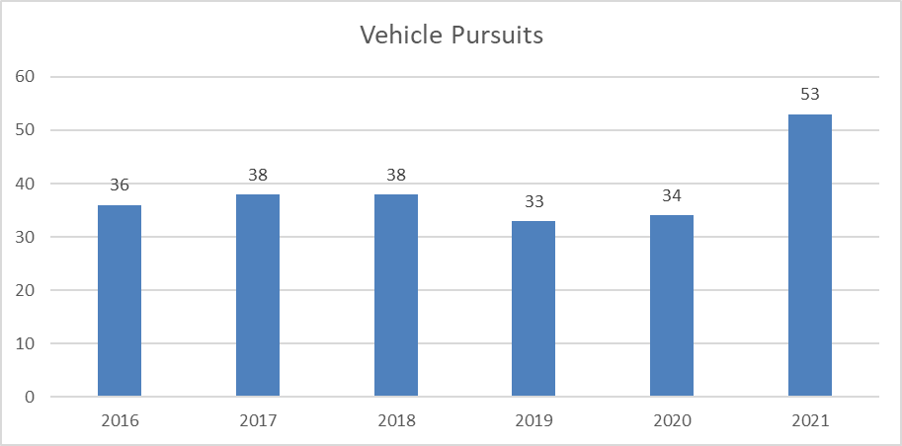

The majority of pursuits, 62%, occurred between the hours of 9pm and 6am.

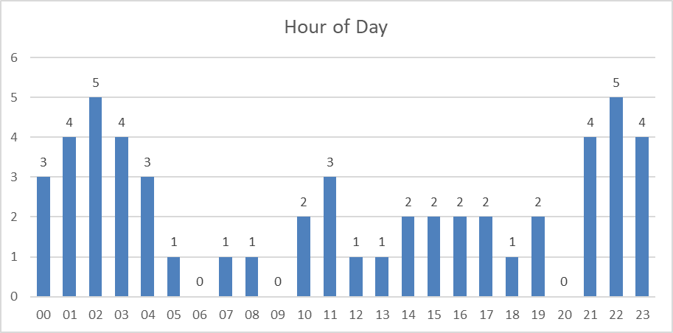

Of the 53 pursuits initiated by the Pearland Police Department, the majority originated from an observed traffic violation. 14 of the 21 pursuits stemming from a crime originated by a citizen calling in the event to the police. Pursuits originating from an observed traffic violation were up significantly over previous years. A breakdown of the reason for the pursuits is depicted in the chart below.

|  |  |  |  |  |  |  |
| --- | --- | --- | --- | --- | --- | --- |
| **Reason** | **2016** | **2017** | **2018** | **2019** | **2020** | **2021** |
| Criminal Investigation | 14 | 11 | 9 | 21 | 17 | 21 |
| DUI / DWI | 3 | 1 | 6 | 2 | 2 | 1 |
| Equipment Violation | 1 | 2 | 6 | 2 | 4 | 5 |
| Traffic Violation | 18 | 23 | 14 | 6 | 10 | 25 |
| Wanted Vehicle / Driver |  | 1 | 3 | 2 | 1 | 1 |
| **Total** | **36** | **38** | **38** | **33** | **34** | **53** |

The average pursuit distance is five miles with 10 pursuits traveling less than one mile. The longest pursuit lasted 31.6 miles. The average top speed was 88 mph and top speeds ranged from 23 mph to 128 mph. 49 percent of pursuits involved a single police vehicle. A breakdown is depicted in the chart below.

|  |  |
| --- | --- |
| **# Police Vehicles** | **Count** |
| 1 | 26 |
| 2 | 8 |
| 3 | 6 |
| 4 | 7 |
| 5 | 3 |
| 6 | 3 |
| **Total** | **53** |

Safety of the officers, suspects and the general public is important in considering when to initiate a pursuit and when to terminate them. Of the 53 pursuits initiated by the Pearland Police Department, 12 of those were terminated. Aside from when a suspect successfully evades, reasons for termination are almost always for reasons of safety. Termination reasons are found in the chart on the below.

|  |  |
| --- | --- |
| **Termination Reason** | **Count** |
| Level Of Offense | 2 |
| Other | 2 |
| Speed | 2 |
| Suspect Evaded | 5 |
| Weather Conditions | 1 |
| **Total** | **12** |

Out of the total documented 55 pursuits, 2 officers received minor injuries related to the pursuit. Three pursuits resulted in suspect injuries as the result of the suspect vehicle losing control and crashing. No citizens were injured in any of the pursuits.

Crashes are an inherent risk when dealing with pursuits. Officers receive hours of training on vehicle operation and police vehicles enjoy a reasonably high level of maintenance, while those being pursued have no training and often have vehicles with questionable equipment and maintenance history. Ten pursuits ended as a result of the suspect’s vehicle crashing.

Aside from pursuits ending in crashes, the chart below shows a breakdown of how pursuits have ended.

|  |  |
| --- | --- |
| **Pursuit Ended** | **Count** |
| Crash | 10 |
| Other | 3 |
| Rolling Roadblock | 1 |
| Spike Strip | 2 |
| Suspect Evades | 3 |
| Suspect Voluntarily Stopped | 22 |
| Terminated | 12 |
| **Total** | **53** |

People try to evade police for several reasons, many are just trying to avoid arrest. Looking at the pursuits that were initiated by Pearland, 35 of the 53 drivers were arrested at the scene. Further, 17 of the drivers continued to flee on foot after the vehicle pursuit ended. Of the known drivers, 8 were not licensed to drive and 5 had a suspended driver’s license.

Five pursuits resulted in use of force requiring a use of force report be documented. Use of force is governed by Policy 502 and a detailed report on the Pearland Police Department’s use of force events can be found on the Department’s website.

Of the 55 documented pursuits in 2021, one pursuit was out of policy. The policy violation did not result in any injuries or property damage and was resolved through counseling and additional training for the officer involved.